Accessing your Public Exam Results through the Student Portal

In line with recent years, Public Exam Results will be made available electronically via the Student Portal. This will provide a system that enables students to electronically access their Exam Results securely.
It is important therefore that you are aware of how to access the Student Portal – and it would be prudent to check that your access is operational before Results Day itself (when IT support may be in higher demand) The IT office is open during weekdays from 10am–4pm and IT staff can be reached by emailing ithelpdesk@emanuel.org.uk or on 0208 8756928.

Method
- Navigate in your web browser to the following address: https://emanuel.students.isams.cloud/api/profile/publicexams/.
- Click on “Sign in via Single Sign On (SSO)” as indicated in red in the image below:
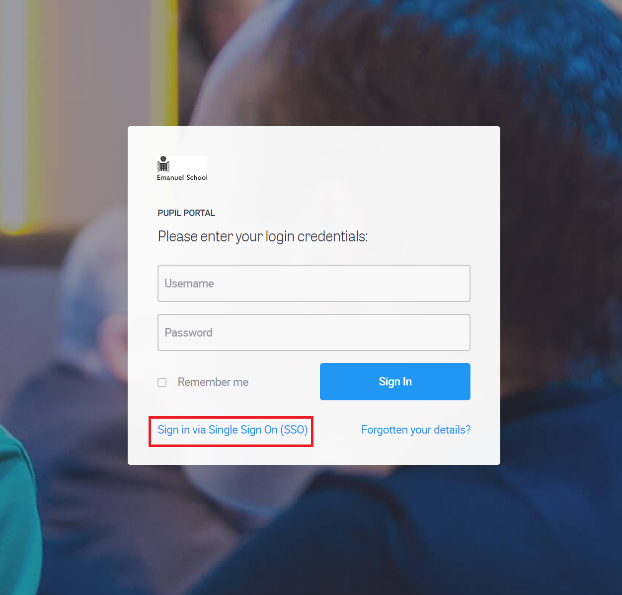

- Enter your school email address then click on “Next”.
- You will then be prompted for your school email password.
- This will log you into the Pupil Portal and you should see several menu items. Click first on “My School Profile” and then “My Public Exams” as shown below.
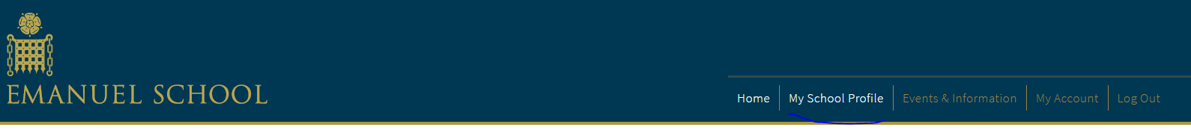

- On the next screen you should select View My Examination Results as shown highlighted in red below. Click this to view your results.
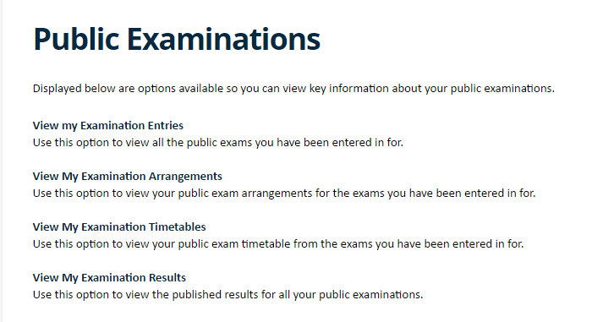

- On the following screen you will be presented with your results. You may need to select the correct Exam Cycle in the top-right as shown highlighted in red below. Please note that this year you will only receive a grade for each of your subjects (there will not be marks for each component as in previous years).
